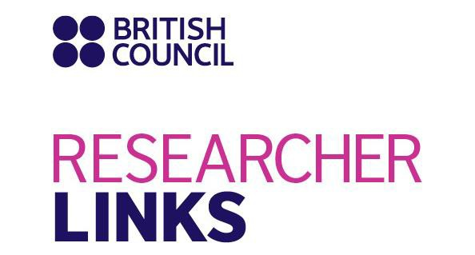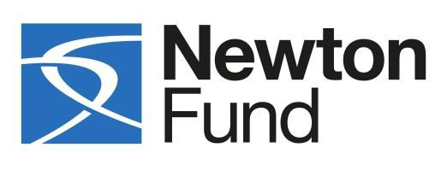

CALL FOR participants to RESEARCHER-LINKS WORKSHOP on
Geohazard Risk Reduction in Unplanned Urban Areas
10-14 September 2018 - Caldas Novas, Brazil

Under the Researcher Links scheme, the British Council and FAPEG will be holding a workshop on the above theme in Caldas Novas, Brazil on 10-14 September 2018. The workshop is being coordinated by Dr Omar Hamza and Dr André C. Silva, and will have contributions from other leading researchers. We are now inviting Early Career Researchers from the UK or Brazil to apply to attend this workshop. All travel and accommodation expenses will be covered by the Newton Researcher Links programme. The application form, with more details on the initiative, is attached and should be sent to o.hamza@derby.ac.uk and ancarsil@ufg.br before the deadline of 16th of April 2018.

Please see this link below for detail on British Council policies that relate to your work- adherence to these policies are British Council Requirements http://www.britishcouncil.org/new/about- us/jobs/folder_jobs/register-as-a-consultant/policies-for-consultants-and-associates/. Please refer to brand guidelines (Annex 3 and as directed by the British Council office in the country where you will be delivering your workshop) when drawing up the application form and any publicity or dissemination activities relating to your workshop.

-----------------------------------------------------------------------------------------------------------------------------------

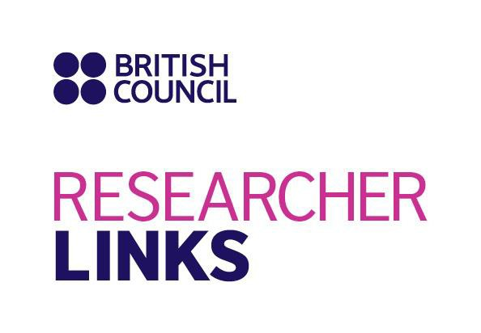
Workshop Title: Geohazard Risk Reduction in Unplanned Urban Areas
UK coordinator: Dr Omar Hamza, University of Derby, UK
Partner Country coordinator: Dr André Carlos Silva, Federal University of Goiás (UFG), Brazil
Discipline: Engineering and Technology
Dates and venue: 10-14 September 2018, Caldas Novas, Brazil

The programme, ‘British Council Researcher Links’ provides opportunities for early career researchers from the UK and internationally to interact, learn from each other and explore opportunities for building long-lasting research collaborations.

As part of this programme, we are now recruiting early career researchers to participate in the above workshop.

The workshop will provide a unique opportunity for sharing research expertise and networking. During the workshops, early career researchers will have the opportunity to present their research in the form of a short paper and oral presentation and discuss this with established researchers from the UK and partner countries. There will be a focus on building up links for future collaborations and participants selected on the basis of their research potential and ability to build longer term links.
The British Council and FAPEG will cover the costs related to the participation to the workshop, including: travel (both international and local), accommodation and meals. Costs for the visa will be covered; however participants will be responsible for making all the necessary arrangements. Although this cost will not be covered by the British Council, participants are encouraged to purchase an adequate travel and medical insurance. The British Council accepts no responsibility for any problems which may occur when the participants are in-country.

Application and Deadline:
The full application below must be completed and submitted by Monday 16th of April 2018 to: o.hamza@derby.ac.uk and ancarsil@ufg.br
Eligibility Criteria:
- Applications must be submitted using the Researcher Links application form (shown below)
- Application must be submitted before the above deadline
- Participants must be Early Career Researchers: Early Career Researchers are defined as holding a PhD (or having equivalent research experience in geohazard assessment with a background in one of the following disciplines: geotechnical and mining engineering, geology and geoenvironmental science, Geomatic and remote sensing) and having preferably up to 10 years post-PhD research experience. They are equivalent to the ‘Recognised Researcher’ and sometimes ‘Experienced Researcher’ categories in the EU framework for researchers’ careers.
http://ec.europa.eu/euraxess/pdf/research_policies/Towards_a_European_Framework_for_ Research_Careers_final.pdf .
  - Participants must have a research or academic position (a permanent post, research contract, or fellowship etc.) at a recognised research institution either in the UK or in Brazil.
  - Please note that participants are expected to attend all sessions of the workshop.

Quality Assessment
  - Experience and relevance of the applicant’s research area to the workshop
  - Motivation and contribution to the aims of the workshop
  - Description of the long term impact expected through the participation in the workshop
  - Ability to disseminate workshop’s outcomes

Selection Procedure:
  - Eligibility check
  - Quality assessment

Notification of results:
Applicants will be notified by email 2 months prior to the workshop.

Equal Opportunities
Equal opportunities and diversity are at the heart of the British Council’s cultural relations ambitions. While recognising that some research fields are dominated by one particular gender, co-ordinators are encouraged to work towards an equal gender balance, promote diversity. They must not exclude applicants on the basis of ethnicity, gender, religious belief, sexual orientation, or disability. Participants’ selection undertaken by workshop organisers must not contravene this policy. Extra support to enable participation of Early Career Researchers with special needs will be given.

Workshop Application Form

1. Applicant
Name and title
Gender (for statistical purposes. This will not affect choice of participants)
Position and institution
Postal address
Email
Phone number
Brief CV (academic career, publications, markers of esteem, and any other relevant
information) – no more than ½ page of A4

2. Abstract – please give a summary of your area of research / Abstract of your short paper

3. Please describe your motivation for attending the workshop and how the workshop matches your
professional development needs
4. Please describe the expected impact of your participation on your personal and professional development, including your ability to work internationally

5. Please indicate how you will disseminate the outcomes of the workshops and the new knowledge/skills you have acquired

6. Workshops will take place in English as standard. Please indicate your ability to work and
communicate in English (Note, translators may be provided if necessary)
Native speaker |  | Good
Excellent |  | Need support

7. Please use this space to give any additional information that you feel is relevant to the applications.

Please note that airport transfer within the UK is not covered. UK participants are expected to cove this cost.
If accepted as a participant you are required to submit a short paper (3-5 pages) at least one month prior to the workshop.

